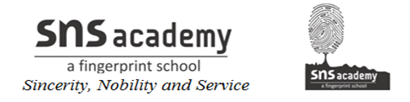

STD: IV SUB: SOCIAL

Lesson -10

Read the clues and solve the word puzzle.

ACROSS
4 A mode of transport
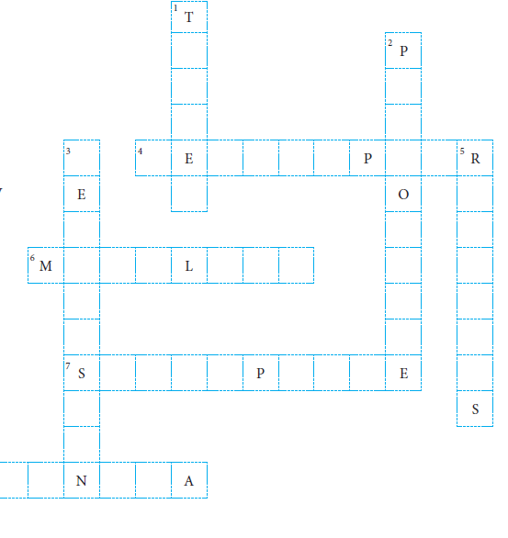
used to drop food
and medicines during
a natural disaster

6 Roads made of stone,
cement and tar

7 A device used by many
to access the Internet

8 A means of
communication
to educate and
entertain people

DOWN
1 A ship that carries oil
and petroleum

2 A place where stamps
can be bought

3 A machine which
shows pictures
about what is
happening around
the world

5 This is considered to be
the lifeline of India

